# CHAPTER 4: System Analysis

## **4.1** Detailed **analysis of the current system.**

mCarFix android app is an android application which has several features which are meant to favor car owners, auto spare part dealers and garages.

Below is the detailed analysis of the application.

### 4.1.1 Flowchart

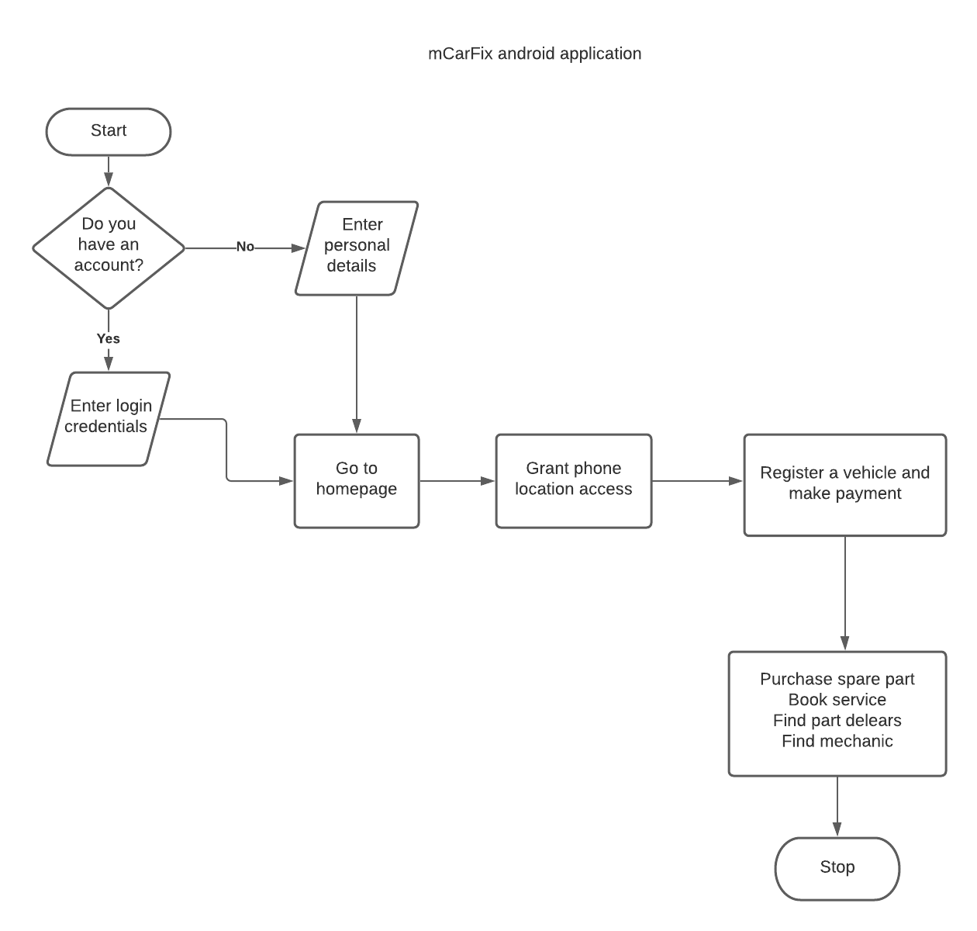

### 4.1.2 Context Diagram

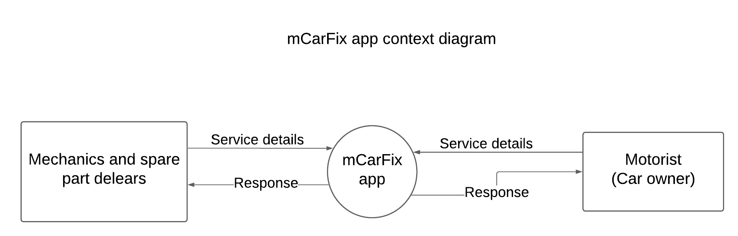

### 

### 4.1.3 Data Flow Diagrams

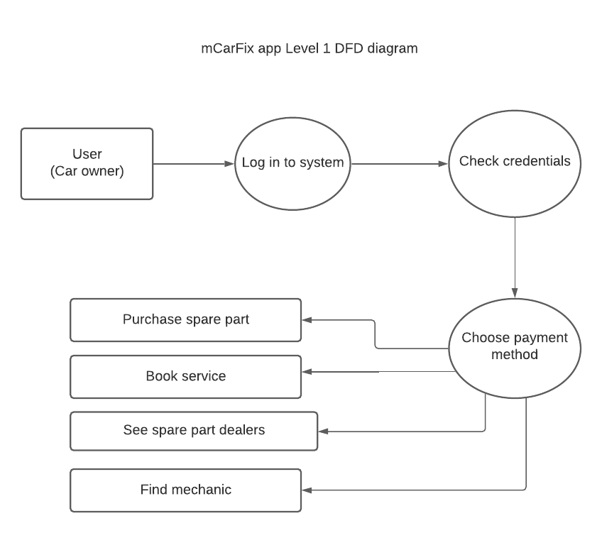

## 

## 4.2 System Requirements

### 4.2.1 Functional requirements

A Functional Requirement (FR) is a description of the service that the software must offer.

The car owner should possess the ability to:

i) Create an account and login.

ii) Choose a payment method in order to use the application features.

iii) Purchase a spare part online.

iv) Book a car repair service.

v) See mechanics on the platform.

### 4.2.2. Non-functional requirements

A non-functional requirement is a specification that describes the system’s operation capabilities and constraints that enhance its functionality.

Reliability - The system is expected to perform well at all times so as to offer the best experience to the user.

Security - The system is expected to keep personal details of its users private.

Availability - Services offered by the application should be present at all times.